John Durham Cathro (“Durrie”):

Durham’s Service Record:
Durham was born on 22 December 1896. He volunteered in 1916 and underwent a military medical examination in Dunedin on 14 March 1916. The resulting records describe him thus:
Age 21 [actually untrue – he was only 19 years and 3 months old at the time! He –deliberately? – smudged his year of birth.]
Height 5 feet 9 inches. Weight 10 stone 2 lbs. Chest 34.5 – 36 inches.
Complexion fair, eyes brown.
Religion - Presbyterian.
He named Kokonga [Central Otago, New Zealand] where his parents had the farm, as his home.
He indicated that he had registered for CMT in Dunedin, and was willing to serve overseas. Durham also stated that at the time of his medical he was still serving in a local regiment – E Company, 10th Regiment. He had joined in 1914.
Durham enlisted into D Coy, 15th Reinforcements, at Trentham on 5 April 1916, Regimental Number 15135, was inoculated on 10 July 1916, and promoted to Lance Corporal on 19 July 1916.
From there, he was sent to Featherston Military Camp.
After serving 112 days in New Zealand, he embarked for England, sailing from Wellington aboard HMT ‘Waitemata’ on 25 July 1916. He disembarked at Devonport on 3 October 1916 after a voyage of 70 days. On the same day his unit marched into Sling Camp on the Salisbury Plain, described as “a cold, miserable place.
From there he left for France 17 days later on 20 October 1916, after only a brief training period. On the following day he marched into camp at Etaples, on the coast, Pas de Calais, N. W. France, where he joined the 2nd Battalion, Otago Regiment NZEF, 10th Coy, thereupon relinquishing his appointment to L/Cpl and reverting to the ranks. He was posted ‘in the Field’ on 9 November 1916. By the 23rd he was at Rouen.
Some months later he became ill, and his subsequent hospitalisation record is as follows:
Sent to hospital (sick) 18/7/17
Admitted No 2 NZ Field Ambulance 18/7/17
Admitted 2 Australian Casualty Clearing Station 18/7/17
Admitted 3 Australian General Hospital Abbeville 19/7/17 (I.C.T. Hand[?])
Admitted No 5 Convalescent Depot, Cayeux 24/7/17
Attached St 9th[?] NZ.I and G B.D,[Base Depot] Etaples 6/8/17
Rejoined Battalion in the field 11/8/17
[reference to I.C.T Hand – that appears to be what is written – is a puzzle. It appears more than once in the records].
. He was killed in action during the Battle of Passchendaele, near Ypres, Belgium, on Friday, 12 October, 1917, a day when within just a few hours, 117 officers and 3179 men from New Zealand were killed or wounded during an attack which advanced the Western Front by just 8 km at the cost of at least 240,000 Allied lives.
So he was just 21 when he was killed. My father, Robert Cathro (Durham’s nephew) has recalled that he was staying with Durham’s parents on the farm at Kokonga when the telegram notifying them of Durham’s death was received. He was sent to find his grand-father, and give him the telegram. It was a terrible message for a little six-year-old boy to have to bring, and he says that he always felt his grand-father never really forgave him for being the bearer of such bad news.
A scroll was much later despatched to his parents at Kokonga on 3/3/21, a plaque was sent on 4/11/21, and a Certificate posted on 2/8/22. The record also shows that he posthumously received the British War Medal on 30 September 1921, and the Victory Medal on 11 August 1922. His body was never recovered.

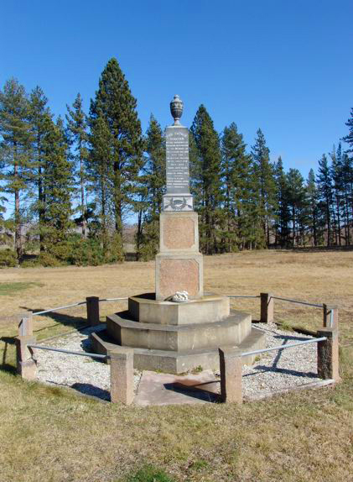
The memorial at the Swinburn Cemetery, unveiled in April 1920,
on which Durham’s name appears:

